Despite Massachusetts’s reputation as a liberal democracy, we’ve got a real issue with government transparency that more accurately might be extremely secretive at best and draconian at worst. Indeed, according to a 21 Mar 2015 article in the Worcester Telegram and Gazette <https://www.telegram.com/article/20150321/NEWS/303219671> , The National Freedom of Information Coalition and Better Government Association gave Massachusetts a 31 out of a possible 100 points in a survey of state responsiveness to public records requests.[1] Only seven states fared worse.

According to a Boston Globe editorial article from 06 Jul 2015 <https://www.bostonglobe.com/opinion/editorials/2015/07/06/putting-teeth-into-mass-public-records-law/N505M7YSUcSRb9omTPAVmO/story.html> , a favorite tactic state agencies used to deter media and citizens from requesting public records was to charge ridiculously high fees.[2] According to the that editorial piece from the Globe though, new Attorney General Maura Healey was working to change things.

January 1st, 2016 was an exciting time for Massachusetts journalists. On that date the “Act to Improve Public Records” went into effect, seemingly ending years of Massachusetts being one of the most secretive state governments in the nation.

Nearly a year later, on December 4th 2016, Healey was praised by local publishers and editors for “prying open access to public records in a state criticized for its secrecy.”[3] That year, Healey sued not one but three prosecutors’ offices for not turning over electronic lists of criminal cases to the *Boston Globe*. According to President of the Massachusetts Newspaper Publishers Association Bill Ketter “She (Healey) has been a champion for us.” Healey responded by saying “I take seriously our job enforcing the open meetings law, it’s about democracy and making sure the public knows what’s going on in their government.” Healey was, seemingly, the first Attorney General in decades willing to fight for transparency. The Secretary of State’s Office was fielding complaints and then referring the journalists and citizens who filed the complaints to the Attorney General who would then take the state agency withholding records to court. One problem remained: hat happens when it is the Attorney General’s office who is the one violating the public records law?

On January 31st , 2019, Dan Glaun of Masslive wrote an article entitled “Massachusetts State Police refuses to disclose union rep pay records, adding to list of hidden public records”. According to the article, the Massachusetts State Police also have a penchant for ignoring the rulings of the Secretary of State’s Public Records division.

While trying to obtain pay records for police union reps, Masslive was denied by the State Police because they determined the records were “pPart of an ongoing federal investigation”. Masslive also appealed their response to the Secretary of State’s office and, despite a favorable ruling from the Secretary of State, the State Police still refuse to even respond to further inquiries.

“The state’s Supervisor of Records Office, which hears appeals of public records denials, has repeatedly ordered the State Police to provide payroll records to MassLive, ruling that the agency has failed to justify their denials.”

Masslive has yet to obtain these records or a response from the State Police.

Reading this article confirmed a personal experience I had been having with the Attorney General’s office as I attempted to obtain public records over the past several years. Now, I think it is important to point out that I am not a journalist or attorney by trade. In September 2012, my wife sent me an article on the arrest of a Massachusetts State chemist, Annie Dookhan. I became fascinated with Dookhan’s case because of my volunteer work in the criminal justice system and my job as a Quality Assurance professional in the biotech industry. I began reading the police report and everything I could get my hands on about the case. What was striking to me was that everything I was reading directly contradicted everything the state was saying to the media about the case. Over the next few years I began to dig deeper and kept uncovering more information that had never been published in the media anywhere: .

In 2017 I asked for and received an audio interview the Attorney General’s office did with infamous former Hinton Lab Chemist Annie Dookhan. On February 21st, 2018 I made a public records request with the Attorney General’s Office for “All interviews (written, audio and video recordings) and investigation summaries, notes and emails for the Attorney General’s investigation into the classification of federally scheduled drugs that are not illegal in MA. The drugs in question could include, but aren’t limited to, Molly, Foxy, Bath Salts and BZP.” The AG’s office responded on March 7th, 2018 and said they identified 326 electronic records and said it would cost $625.00 to review them. I readily accepted this and sent the AG’s office a check--and then, I didn’t hear anything for over a month and a half.

On April 20th 2018, the AG’s office told me they were still working on the request. Four months later, on August 24th 2018, they again said they were still working on the request. Nearly a month later, on September 17th 2018, they again said they were still working on it. Finally, on October 12th, 2018, eight months after my initial request, the Attorney General sent me 96 records (a third of the original estimate) and a check for $312--because of the reduced record amount, I assumed. The records consisted of a series of emails and one interview with former lab manager for the Amherst crime lab.

The interview was heavily redacted. I found this odd because the Attorney General’s office’s excuse for the heavy redactions was that the interview could potentially be a threat “to the security of individuals or buildings in the Commonwealth of Massachusetts.” How could an interview with a lab manager from 2016 possibly threaten any person or building’s safety? I challenged this notion with the Secretary of State’s office and they agreed that the Attorney General’s office needed to provide an explanation as to how these records are a threat to public safety within ten days of their ruling.

On Feburary 1st 2019, the Attorney General’s office contacted me and the Secretary of State’s office saying that they were going to have a response to me no later than Feburary 5th, 2019. As of this writing, March 17th, 2019, I have yet to receive a response . This could be due to a backlog of requests, or staffing issues, or it could be due to the Attorney General just not wanting to comply with the public records laws to cover something up. Before the reader jumps to the conclusion that I’m a conspiracy theorist, let me go back and explain how the public records requests worked when I was uncovering all those loose threads in the Annie Dookhan case. . Four years prior to submitting these requests, in February of 2015, I submitted a record request to the Department of Public Health asking for emails between former Massachusetts chemist Annie Dookhan and any law enforcement officials. It took about a month for them to respond to my initial request. They needed clarification as to what law enforcement official I was talking about. I said any email between an ADA or police officer that looked like Dookhan was wanting to help the ADAs.

In June of 2015, after about six months of waiting and several follow up emails, the DPH sent me about fifteen emails that showed exactly what I was looking for. The first one I read was dated September 10th 2012 and was an internal DPH email regarding an internal DPH investigation into Dookhan five months after she was arrested. There were several attachments on the email and in the body of the email the author (a high level DPH official) said the department’s IT department found “a bunch of photos of ADA Papachristos” on Dookhan’s work computer. Why would a chemist have photos of an ADA whose cases she was a witness for on her work computer? The first attachment on the email gave me the answer:

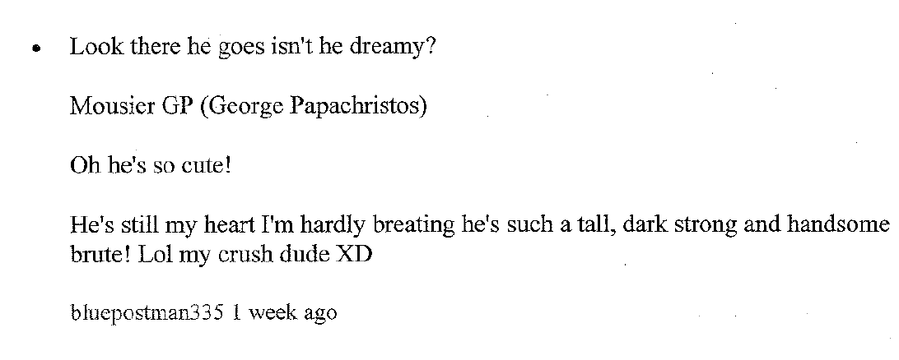

This poem was written by Dookhan and found by the Department of Public Health after Dookhan was let go. For me, this was confirmation that the Inspector General was misleading the public when they said in their 2014 report on the Lab that they couldn’t find a motive as to why Dookhan rigged test results but it “definitely was not to help prosecutors convict criminal defendants.” You could imagine my further disbelief as I read email after email of Dookhan celebrating the conviction or plea of a criminal defendant to prosecutors and her emails “joking” about adding more time to a defendant’s sentence if they “pissed her off” and didn’t accept a plea deal from prosecutors. Naturally I wanted to see all of Dookhan’s emails to see what else was in there. I submitted another request in June of 2015 for all of the materials used by the OIG in their investigation of Dookhan.

After many follow up emails and much hounding, I opened a complaint against the OIG with the Secretary of State’s office on October 14th, 2015. Two months later the Secretary of State gave me their response and they ruled in my favor, forcing the DPH to send me all of Dookhan’s emails used in the OIG investigation. The DPH sent me a CD with all of Dookhan’s emails in January of 2016, nearly a year after my initial request. Were these delays just about trying to cover up information about the Drug Lab case or was this treatment part of an ongoing pattern that persisted regardless of what the laws dictated?

Although the Sunshine Act promised increased government transparency and accountability, the execution has been anemic, despite what many in the media and Attorney General’s office want the public to believe. Although there was good intention to the new public records law, the execution in tied to the age-old question, “Who will police the police?” The current policy is that the police and Attorney General police themselves. What can be done though? If this is how Massachusetts is, every other state must be worse, right?

Massachusetts and Michigan are the only two states in the nation that still don’t subject their Governor’s offices to public records requests. This means the Governor’s offices of both states do not have to even respond to public records requests let alone give the public the records they are requesting. Michigan, unlike Massachusetts, is actually trying to do something about their lack of transparency.

Ryan Dunn wrote in *The Blade* about Michigan’s new governor Gretchen Whitmer’s attempt to “expand public records access for a state that has historically lagged in the field.”[4]

Michigan isn’t exactly known for having a government by the people and for the people. Gretchen Whitmer is, apparently, trying to change all that.

Whitmer wants to create “transparency liaisons” in government offices to help field questions and steer people in the right direction for their public records requests. Any request that is denied must have an explanation and let people know that they can appeal the decision. Not perfect, but definitely a step in the right direction seeing that Michigan received an F ranking in the Center for Public Integrity. Massachusetts has been given a D+ in the same report.

Part of the problem in Massachusetts is that we have convinced ourselves we are “too liberal” without looking to see how our government is run. For the past six years I have been looking under the fingernails of my state’s government and I can safely say my home state is far from liberal when it comes to anything related to criminal justice and related issues of government transparency. This reality needs to be recognized and an effort for greater transparency needs to be made if Massachusetts is ever to truly get a government of the people, by the people and for the people.

1. <https://www.telegram.com/article/20150321/NEWS/303219671>
2. <https://www.bostonglobe.com/opinion/editorials/2015/07/06/putting-teeth-into-mass-public-records-law/N505M7YSUcSRb9omTPAVmO/story.html>
3. <https://www.eagletribune.com/news/healey-praised-for-opening-access-to-public-records/article_43917a92-687f-5d8c-85df-2d6294162f3b.html>
4. <https://www.toledoblade.com/local/politics/2019/02/18/michigan-whitmer-expands-access-public-records/stories/20190219008>